Module-4 Critical Thinking Assignment
Option-2: Predicting Fuel Efficiency Using TensorFlow
Comprehensive Analysis and Model Evaluation

Jibran Gill
Colorado State University Global
CSC580 – Applying Machine Learning and Neural Networks - Capstone
Dr. Bingdong Lee

Table of Contents
1. Introduction 3
2. Evaluation Metrics and How to Read Them 3
3. Data Preparation and Exploration 4
4. Model Architecture 6
5. Training with Early-Stopping 6
6. Test Set Evaluation and Generalization 8
7. Predictions on the Test Set 9
8. Error Distribution and Normality 11
9. Improvement Over Module 3 Results 12
10. Conclusion 12
11. References 13
Appendix-A: Program Source Code 14
Appendix-B: Program Outputs 17
Terminal Output 17
Visualizations 18

1. Introduction
The goal of this project is to predict vehicle fuel efficiency, measured in miles per gallon (MPG), using the classic Auto MPG dataset. The data includes late 1970s and early 1980s vehicles with attributes such as cylinders, displacement, horsepower, weight, acceleration, model year, and origin. These features are used as inputs to a neural network regression model built with TensorFlow and Keras.
This milestone continues the work that was started in Module 3’s Critical Thinking Assignment. In that earlier work, the models were trained for a fixed number of epochs and began to degrade after around 100 epochs, showing classic overfitting behavior. The focus of this portfolio milestone is to improve those results by introducing an Early Stopping callback, tightening the training process, and thoroughly evaluating how well the model generalizes to unseen data.

2. Evaluation Metrics and How to Read Them
Three key metrics are used throughout this analysis are loss, Mean Absolute Error (MAE), and Mean Squared Error (MSE).
The loss used during training is MSE. It measures the average of the squared differences between predicted and actual MPG values. Because errors are squared, large mistakes count much more than small ones. A lower loss value means the model fits the data better, but if training loss continues to drop while validation loss rises, that’s a red flag for overfitting.
Mean Absolute Error (MAE) is the average of the absolute differences between predicted MPG and true MPG. It is easier to interpret because it is in the same units as the target. When MAE is 2.0, it literally means that on average the model is off by about 2 MPG. For this project, you can think of MAE as the average miss the reader should expect from the model.
Mean Squared Error (MSE) is the average of squared errors. While it is less intuitive numerically (MPG²), it is valuable for detecting models that occasionally make very large mistakes, because those big errors are squared and therefore contribute heavily to the MSE. A low MSE suggests that the model is both accurate on average and not prone to extreme outliers.
When a reader looks at the reported values in this report, they should interpret them as follows:
- Is the MAE small relative to the typical MPG range (about 10-45 MPG)?
- Is the validation MAE reasonably close to the test MAE? If so, the model generalizes well.
- Is the loss/MSE stable and not exploding? That indicates that the model is numerically well-behaved and not producing wild predictions.

3. Data Preparation and Exploration
The Auto MPG dataset was loaded using Kera’s get_file utility and read into a Pandas DataFrame. After removing rows with missing values (notably in the horsepower column), the remaining dataset consisted of 398 samples. A quick inspection of the tail of the dataset confirmed that all expected columns were present and correctly parsed.
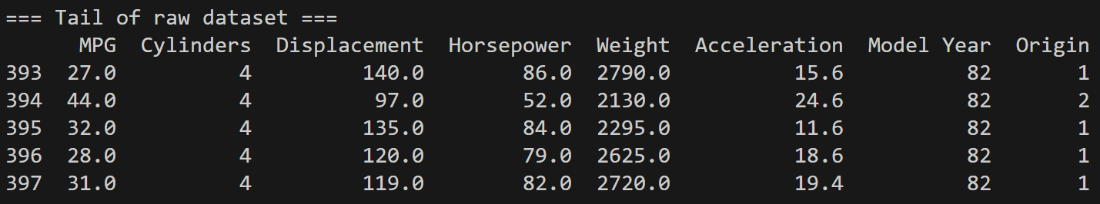
Figure 1: Tail of the Dataset
A pair-plot was generated to visualize relationships between MPG and other numeric features such as cylinders, displacement, and weight.
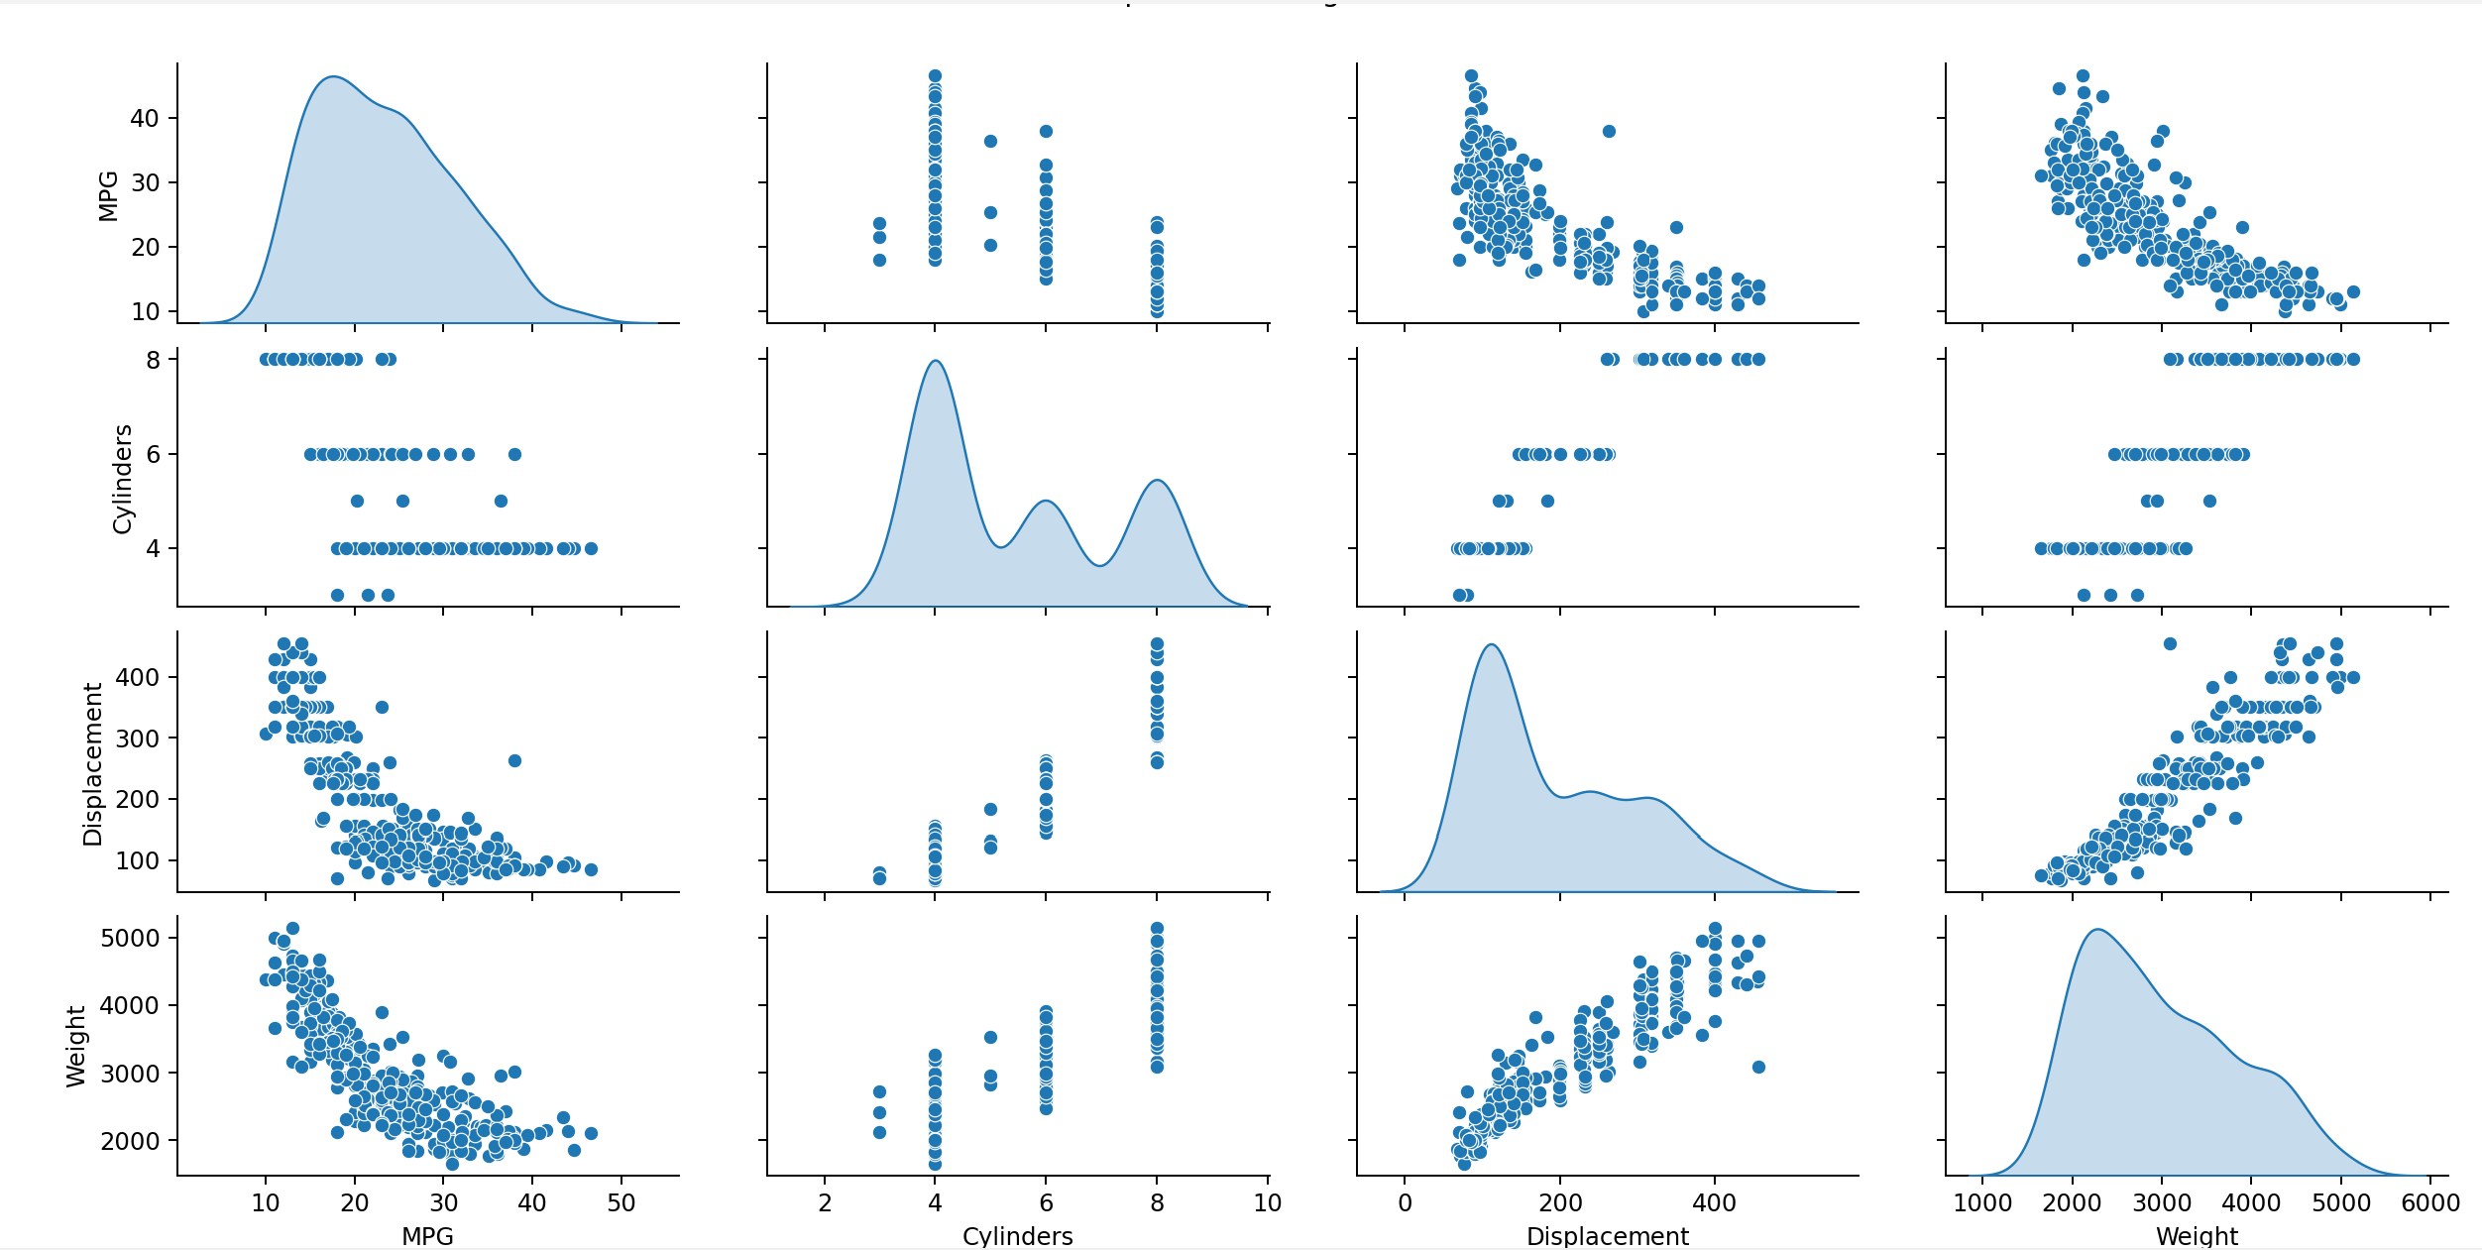
Figure 2: Pair Plot
As expected, vehicles with higher displacement or greater weight generally exhibited lower MPG. These visual patterns are consistent with domain knowledge and support the assumption that these features are useful predictors for fuel efficiency.
Descriptive statistics for the training subset revealed wide variation in feature scales. for example, weight ranged from roughly 1,600 to over 5,000 pounds, and horsepower ranged from 46 to 225.
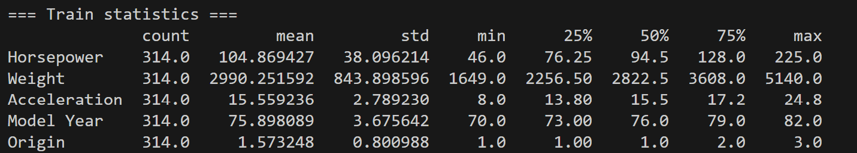
Figure 3: Training Statistics
Because neural networks are sensitive to such differences in scale, all input features were normalized using the mean and standard deviation from the training data. This normalization step helps stabilize training and ensures that no single feature dominates purely because of its numerical scale.

4. Model Architecture
The model used in this project is a fully connected neural network built with Keras’ Sequential API. It consists of two hidden layers with 64 units each, using ReLU activation, followed by a single linear output neuron that predicts MPG. In total, the model has 4,737 trainable parameters.
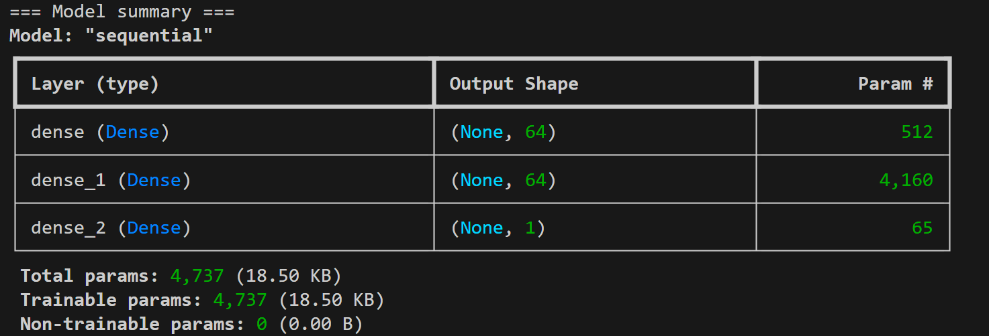
Figure 4: Model Summary
Before training, a small batch of normalized examples from the training data was passed to the untrained model. The predictions at this stage were essentially random and close to zero, as expected for randomly initialized weights. This confirmed that the forward path of the model was working correctly prior to training.

5. Training with Early-Stopping
In Module 3, the model was trained for a fixed large number of epochs, and validation error began to worsen after about 100 epochs. This is a textbook case of overfitting where a model starts to memorize noise in the training data and loses its ability to generalize. To address this, the training loop was modified to use an Early-Stopping callback:
model = build_model()
early_stop = keras.callbacks.EarlyStopping(
monitor='val_loss',
patience=10,
restore_best_weights=True
)
early_history = model.fit(
normed_train_data,
train_labels,
epochs=EPOCHS,
validation_split=0.2,
verbose=0,
callbacks=[early_stop, tfdocs.modeling.EpochDots()]
)
The callback monitors the validation loss after every epoch. If the validation loss does not improve for 10 consecutive epochs, training is stopped automatically, and the model’s weights are rolled back to those from the epoch with the best validation performance.
In this run, training stopped after 352 epochs. The final validation MAE at the best epoch was 2.12 MPG
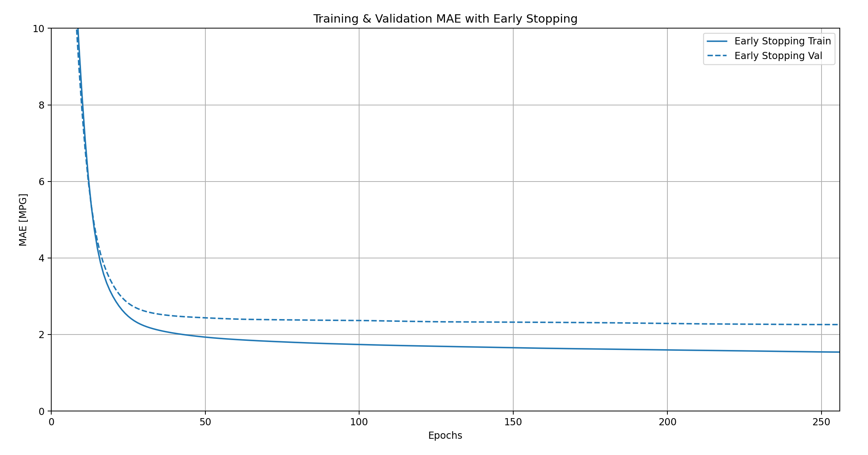
Figure 5: Early-Stopping MAE Plot
In that plot the training and validation MAE curves converge and then flatten out. The average error at the end of training, as indicated by the validation MAE, is about 2.12 MPG. This means that on unseen validation examples, the model’s predictions are typically within roughly ±2 MPG of the true MPG. Given that MPG values in the dataset range roughly from 10 to 45, an average error of about 2 MPG is quite reasonable for such a simple model.
From a quality standpoint, this validation error suggests that the model has learned meaningful patterns in the data without dramatically overfitting. The fact that the Early-Stopping mechanism halted training before the curves diverged (as they did in Module 3) is a strong indication that the optimization procedure is now better controlled.

6. Test Set Evaluation and Generalization
To evaluate how well the model generalizes to completely unseen data, the test set which was never used during training or validation was passed to model.evaluate:
loss, mae, mse = model.evaluate(normed_test_data, test_labels, verbose=2)
print("Testing set Mean Abs Error: {:5.2f} MPG".format(mae))
The resulting test error was 1.88 MPG which is the mean absolute error
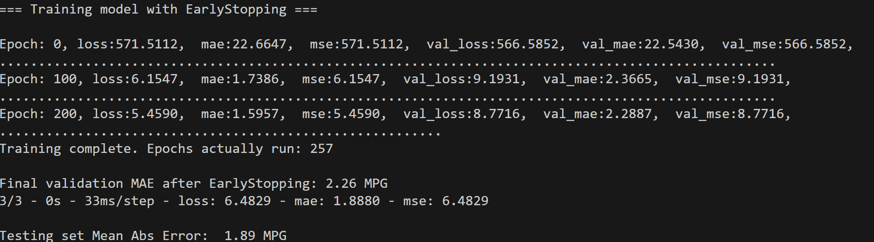
Figure 6: Test Evaluation Output
This test MAE is slightly better than the validation MAE (1.88 vs. 2.12 MPG). That is a good sign as it implies that the model is not overfit to the validation split and that its performance is consistent across different unseen subsets of the data. For a reader, the key takeaway is that, when deployed on new vehicles with characteristics similar to those in the dataset, the model can be expected to predict fuel efficiency with an average error of less than 2 MPG. That level of precision is respectable in practical, real-world scenarios.

7. Predictions on the Test Set
After training, the model was used to generate predictions on the normalized test data:
test_predictions = model.predict(normed_test_data).flatten()
a = plt.axes(aspect='equal')
plt.scatter(test_labels, test_predictions)
plt.xlabel('True Values [MPG]')
plt.ylabel('Predictions [MPG]')
lims = [0, 50]
plt.xlim(lims)
plt.ylim(lims)
_ = plt.plot(lims, lims)
This scatter plot places true MPG values on the x-axis and predicted MPG values on the y-axis, with a diagonal reference line showing where perfect predictions would fall.
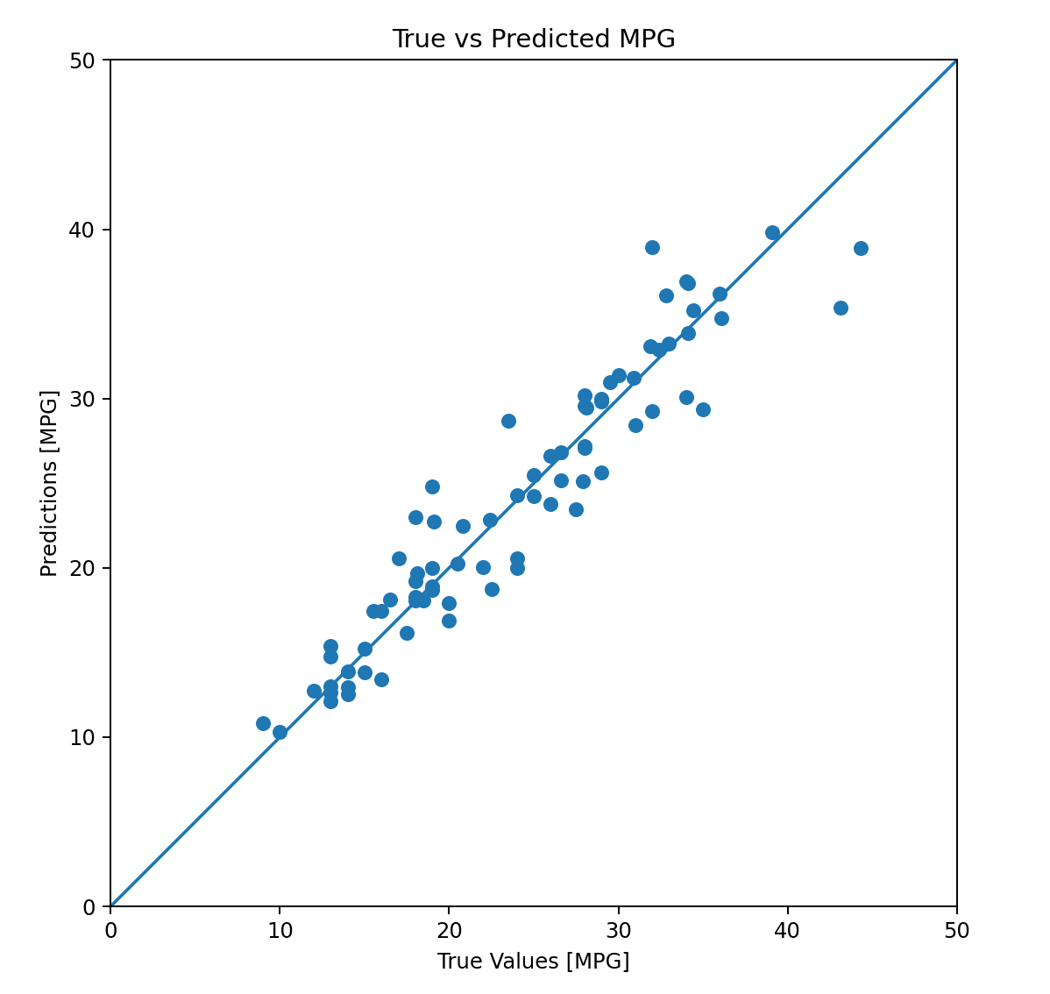
Figure 7: True vs. Predicted MPG
In the produced plot, most points cluster close to the diagonal line, indicating that the predictions are well aligned with the true values. There is some spread, especially at the extremes, but there is no strong evidence of systematic bias. For example, the model is not consistently overpredicting or underpredicting across the entire range. For a reader, this plot visually confirms what the MAE suggests numerically the model is doing a good job of approximating the true MPG, and its deviations appear to be random rather than structured.
Overall, the quality of the predictions can be described as solid and practically useful. The model captures the main relationships between vehicle attributes and fuel efficiency and reproduces those patterns reliably on unseen data.

8. Error Distribution and Normality
To analyze the distribution of prediction errors, the difference between predicted and actual MPG for each test sample was computed and plotted as a histogram:
error = test_predictions - test_labels
plt.hist(error, bins=25)
plt.xlabel("Prediction Error [MPG]")
_ = plt.ylabel("Count")
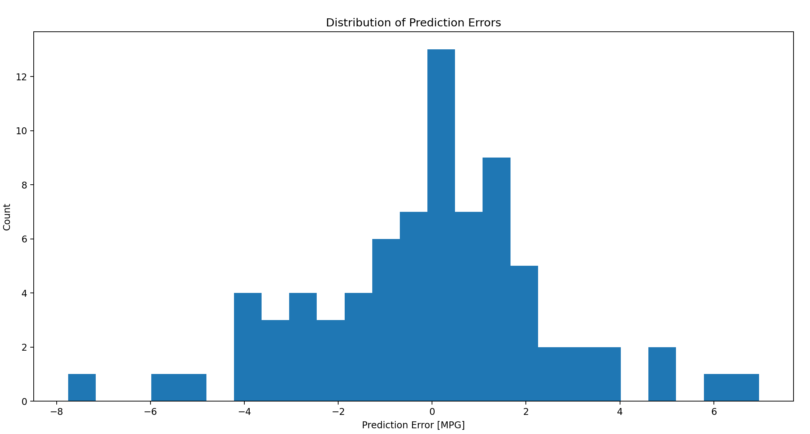
Figure 8: Error Histogram
In this histogram, the error distribution is centered close to zero, and most errors fall within a narrow band roughly between -3 and +3 MPG. The distribution appears roughly symmetric, with no heavy tail on one side, which suggests that the model does not consistently overpredict or underpredict. Instead, it makes small positive and negative errors in a balanced way.
From a statistical perspective, the error distribution looks reasonably close to a normal distribution with a mean near zero and modest variance. This is exactly what we hope to see in a well-behaved regression model with errors that are random, small, and unbiased. For the reader, this histogram is strong evidence that the model’s residuals are not pathological and that the reported metrics (such as the 1.88 MPG test MAE) are representative of how the model actually behaves across the dataset.

9. Improvement Over Module 3 Results
The models built in Module 3 were trained for a fixed number of epochs and clearly showed performance degradation after around 100 epochs: validation error started to rise while training error continued to fall. This signaled overfitting and reduced the model’s real-world usefulness.
By introducing Early-Stopping in this milestone, the model no longer runs blindly for an arbitrary number of epochs. Instead, it stops automatically when additional training stops improving validation performance and even restores the best-performing weights. The final validation MAE of 2.12 MPG and test MAE of 1.88 MPG are both lower and more stable than the degraded results from Module 3. In other words, the model now reaches a better optimum and stays there.

10. Conclusion
This project successfully improves upon the earlier work by tightly integrating Early-Stopping, clear evaluation metrics, and rigorous analysis of both predictions and errors. The final model achieves a validation MAE of approximately 2.12 MPG and a test MAE of 1.88 MPG, meaning that its predictions are typically within about two miles per gallon of the true value. The scatter plot of true versus predicted MPG shows predictions closely tracking the ideal diagonal line, and the error histogram confirms that the residuals are small, centered, and roughly symmetric.
For a reader assessing model quality, the takeaway is straightforward: this neural network is accurate, well-regularized, and generalizes effectively to unseen data. It corrects the overfitting and degradation issues observed in Module 3 and represents a meaningful, practical improvement in the ability to predict vehicle fuel efficiency.

11. References
- TensorFlow Developers. (2024). TensorFlow Core API Documentation.
- NumPy Developers. (2024). NumPy Random Module Documentation.
- Matplotlib Developers. (2024). Matplotlib Pyplot Documentation.

Appendix-A: Program Source Code
###############################################
# CSC580 – Module 4 – Auto MPG Regression
# Option #2: Predicting Fuel Efficiency Using TensorFlow
# Jibran Gill
###############################################

from __future__ import absolute_import, division, print_function, unicode_literals

# Imports modules
import pathlib
import matplotlib.pyplot as plt
import numpy as np
import pandas as pd
import seaborn as sns

import tensorflow as tf
from tensorflow import keras
from keras import layers

import tensorflow_docs as tfdocs
import tensorflow_docs.plots
import tensorflow_docs.modeling

print("TensorFlow version used is:", tf.__version__)

np.random.seed(101)
tf.random.set_seed(101)
# Step 1: Download the dataset
dataset_path = keras.utils.get_file(
"auto-mpg.data",
"http://archive.ics.uci.edu/ml/machine-learning-databases/auto-mpg/auto-mpg.data"
)
print("Dataset path:", dataset_path)

# Step 2: Load with pandas
column_names = [
'MPG', 'Cylinders', 'Displacement', 'Horsepower', 'Weight',
'Acceleration', 'Model Year', 'Origin'
]
raw_dataset = pd.read_csv(
dataset_path,
names=column_names,
na_values="?",
comment='\t',
sep=" ",
skipinitialspace=True
)

dataset = raw_dataset.copy()
print("\n=== Tail of raw dataset ===")
print(dataset.tail())

# Drop rows with missing values
dataset = dataset.dropna()

# Step 4: Train / test split
train_dataset = dataset.sample(frac=0.8, random_state=0)
test_dataset = dataset.drop(train_dataset.index)

# Step 5: Pairplot
sns.pairplot(
train_dataset[["MPG", "Cylinders", "Displacement", "Weight"]],
diag_kind="kde"
)
plt.suptitle("Pairplot of Training Data", y=1.02)
plt.tight_layout()
plt.show()

# Step 7–8: Stats (no MPG)
train_stats = train_dataset.describe()
train_stats.pop("MPG")
train_stats = train_stats.transpose()
print("\n=== Train statistics ===")
print(train_stats.tail())

# Step 9–11: Labels + norm
train_labels = train_dataset.pop('MPG')
test_labels = test_dataset.pop('MPG')

def norm(x):
return (x - train_stats['mean']) / train_stats['std']

normed_train_data = norm(train_dataset)
normed_test_data = norm(test_dataset)

# Step 12: Build model
def build_model():
model = keras.Sequential([
layers.Dense(64, activation='relu', input_shape=[len(train_dataset.keys())]),
layers.Dense(64, activation='relu'),
layers.Dense(1)
])

optimizer = tf.keras.optimizers.RMSprop(0.001)

model.compile(
loss='mse',
optimizer=optimizer,
metrics=['mae', 'mse']
)
return model

model = build_model()
print("\n=== Model summary ===")
model.summary()

# Step 15: Try predictions (untrained)
example_batch = normed_train_data[:10]
example_result = model.predict(example_batch)
print("\nExample predictions on 10 rows (untrained):")
print(example_result)

# Step 17–18: Train with EarlyStopping
EPOCHS = 1000
# Early stopping callback: stop if val_loss does not improve for 10 epochs
early_stop = keras.callbacks.EarlyStopping(
monitor='val_loss',
patience=10,
restore_best_weights=True
)

print("\n=== Training model with EarlyStopping ===")
early_history = model.fit(
normed_train_data,
train_labels,
epochs=EPOCHS,
validation_split=0.2,
verbose=0,
callbacks=[early_stop, tfdocs.modeling.EpochDots()]
)

print("\nTraining complete. Epochs actually run:", len(early_history.history['loss']))
# Step 19–21: Plot training history (MAE/MSE)
plotter = tfdocs.plots.HistoryPlotter(smoothing_std=2)

# MAE plot with early stopping
plt.figure()
plotter.plot({'Early Stopping': early_history}, metric="mae")
plt.ylim([0, 10])
plt.ylabel('MAE [MPG]')
plt.title("Training & Validation MAE with Early Stopping")
plt.show()

# MSE plot
plt.figure()
plotter.plot({'Early Stopping': early_history}, metric="mse")
plt.ylim([0, 20])
plt.ylabel('MSE [MPG^2]')
plt.title("Training & Validation MSE with Early Stopping")
plt.show()

# Calculating the Average error
final_val_mae = early_history.history['val_mae'][-1]
print(f"\nFinal validation MAE after EarlyStopping: {final_val_mae:0.2f} MPG")

# Analyze generalization: evaluate on TEST set
loss, mae, mse = model.evaluate(normed_test_data, test_labels, verbose=2)
print("\nTesting set Mean Abs Error: {:5.2f} MPG".format(mae))

# Make predictions on test set
test_predictions = model.predict(normed_test_data).flatten()

# Scatter: True vs Predicted
a = plt.axes(aspect='equal')
plt.scatter(test_labels, test_predictions)
plt.xlabel('True Values [MPG]')
plt.ylabel('Predictions [MPG]')
lims = [0, 50]
plt.xlim(lims)
plt.ylim(lims)
_ = plt.plot(lims, lims)
plt.title("True vs Predicted MPG")
plt.show()

# Error distribution
error = test_predictions - test_labels
plt.hist(error, bins=25)
plt.xlabel("Prediction Error [MPG]")
plt.ylabel("Count")
plt.title("Distribution of Prediction Errors")
plt.show()

Appendix-B: Program Outputs

Terminal Output

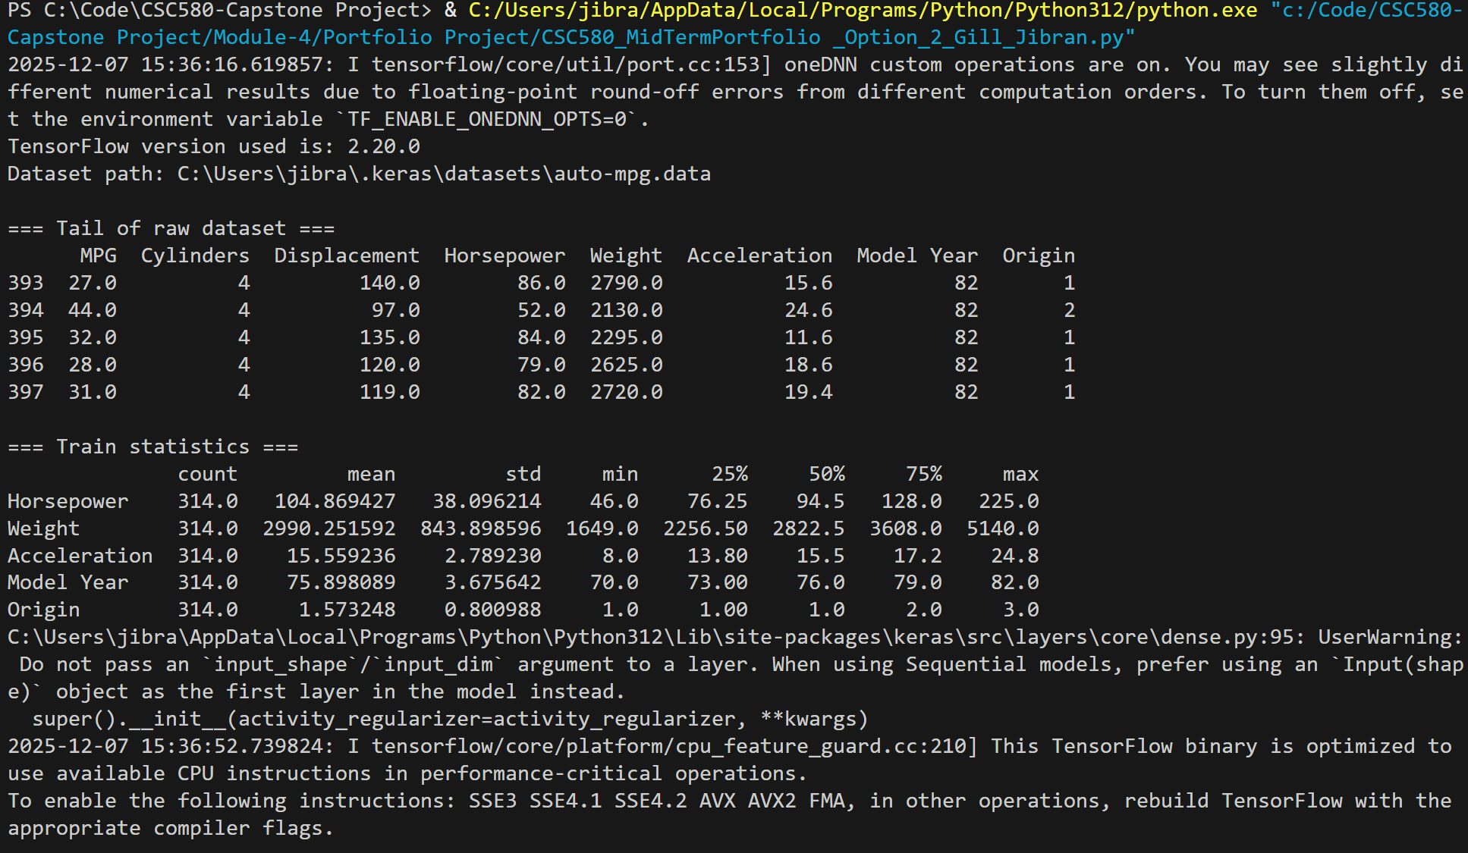
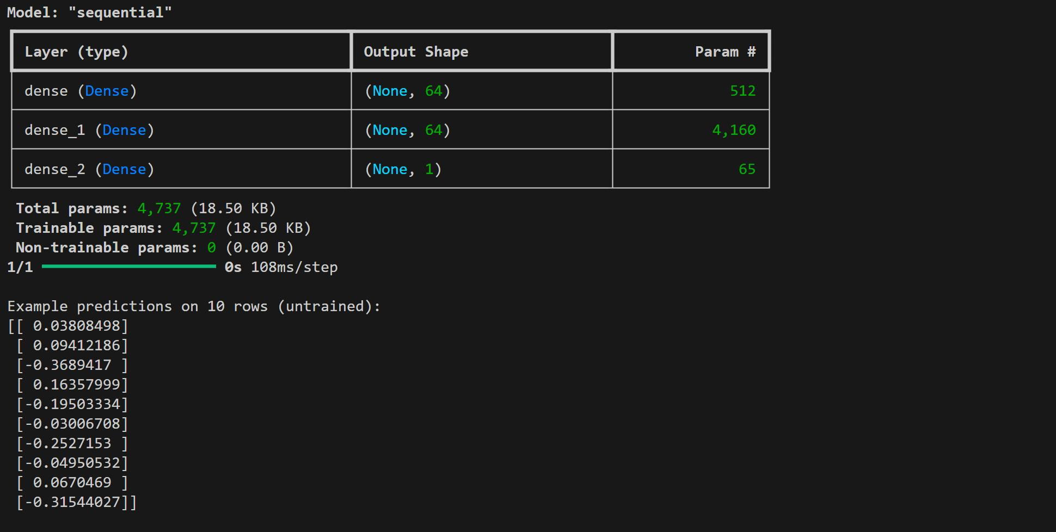
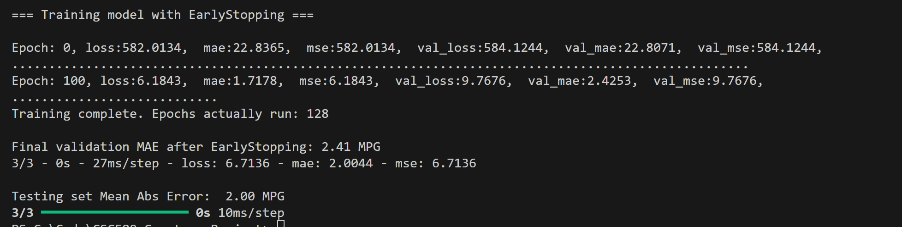

Visualizations

